
Software Engineering Department

Capstone Project Phase B – 61999

Authorship Arabic texts using Deep Impostors method

26-2-D-18

https://github.com/nour-dabbah/CapstoneProject.git

Nour Dabbah | Nour.Dabbah @e.braude.ac.il
Nuwar Dabbah | Nuwar.Dabbah@e.braude.ac.il

Supervisors:
Dr. Renata Avros
Prof. Zeev Volkovich

Abstract

Authorship Attribution in Arabic texts poses significant challenges due to the language’s rich morphology, stylistic diversity, and historical variation. This project presents an adaptation of the Deep Impostors methodology for Arabic authorship attribution , inspired by prior research on literary texts in other languages. The proposed framework leverages contextual embeddings generated by AraBERT and employs impostor based comparisons to capture stylistic behaviour across document segments. By transforming texts into stylometric signals and analysing their similarities, the approach aims to distinguish between authentic and non authentic works attributed to a specific author.

Keywords: Authorship Attribution, Arabic Text Analysis, Deep Impostors, AraBERT, Stylometric Analysis.

Table of Contents
- introduction 4
- Scope of This Document 4
- Case Study: Al-Mutanabbi 4
- Proposed Solution 5
- System Overview 6
- Algorithmic Pipeline 6
- Experiment Setup 7
- Dataset 7
- Preprocessing 10
- Model Configuration 10
- Research Process 12
- Implementation Details 12
- Challenges and Adjustments 13
- Experiment Results 14
- Classifier Training Performance 14
- Aggregated Authorship Decision 15
- Poems Flagged as Suspicious 16
- Signal and Distance Based Analysis 17
- Validation via Control Samples 18
- Conclusion and Future Work 19
References 20
User Guide 21
Maintenance Guide 24

- introduction
Authorship attribution and verification aim to determine whether a text was produced by a specific author, based on stylistic consistency rather than content. This task has grown in importance with the expansion of digital textual archives, particularly for classical literary corpora where authorship is sometimes uncertain or contested. Applying computational authorship analysis to Arabic is especially challenging: the language's rich morphology, frequent attachment of clitics and affixes, orthographic variation, and general lack of diacritics all introduce noise that degrades methods originally designed for less morphologically complex languages.
This project addresses these challenges by implementing a research framework for Arabic authorship verification based on the Deep Impostors methodology. Rather than training a classifier to recognize the target author directly, the framework reframes verification as a relative stylistic comparison problem: a series of binary classifiers are trained exclusively on pairs of impostor authors, and are then used to score how the target author's writing behaves relative to each impostor pair. These per pair scores are aggregated into stylometric signals, compared using Dynamic Time Warping, and finally analyzed with Isolation Forest and clustering to flag documents whose stylistic behavior deviates from the dominant pattern.
  - Scope of This Document
This document presents Phase B of the capstone project and focuses on the implementation, experimentation, and evaluation of the framework proposed in Phase A. While Phase A introduced the conceptual model, theoretical background, and planned methodology, this phase documents how that methodology was actually translated into a working system, including the specific architecture, hyperparameters, and results obtained by running the complete pipeline end to end.
Where implementation details diverge from what was originally planned in Phase A for example, the specific classifier architecture or clustering algorithm used this document describes the system as implemented, and notes explicitly where and why it diverges from the Phase A proposal.
  - Case Study: Al-Mutanabbi
Abū al-Ṭayyib Aḥmad ibn al-Ḥusayn al-Mutanabbi (915–965 CE) is widely regarded as one of the greatest poets in the Arabic literary tradition. His poetry is distinguished by a highly assertive rhetorical voice, dense use of hyperbole and aphorism, recurring themes of pride, ambition, and heroism, and a distinctive command of classical Arabic meter and diction. This strong, recognizable stylistic signature combined with the survival of a large corpus of poems attributed to him makes Al-Mutanabbi a well suited target author for computational authorship verification.
To evaluate the target author's writing against alternative stylistic sources, a set of 25 impostor poets was selected, spanning a broad range of periods, genres, and poetic registers from Abbasid court poets and wine poetry (Abū Nuwās) to mystical and Sufi verse (Ibn ʿArabī, ʿAbd al-Ghanī al-Nābulsī), ascetic poetry (Abū al-ʿAtāhiya), and philosophical verse (Abū al-ʿAlāʾ al-Maʿarrī), among others. This diversity is intentional: it exposes the classifiers trained at each stage to a wide range of contrastive stylistic patterns, rather than a narrow stylistic neighborhood, which strengthens the discriminative power of the resulting stylometric signals.
To validate that the framework does not systematically over flag genuine writing, two well established, canonically accepted Al-Mutanabbi poems including his celebrated satire against Kāfūr al-Ikhshīdī, "ʿĪdun bi-ʾayyati ḥālin ʿudta yā ʿīd" were duplicated and inserted into the evaluation corpus as control samples. A reliable framework should consistently classify these as authentic; the results in Chapter 5 confirm this behavior.
- Proposed Solution
This section presents the implemented authorship verification framework. The system described here is fully implemented and was executed end to end on the Al-Mutanabbi corpus described in Chapter 3.
Figure 1: pipeline diagram
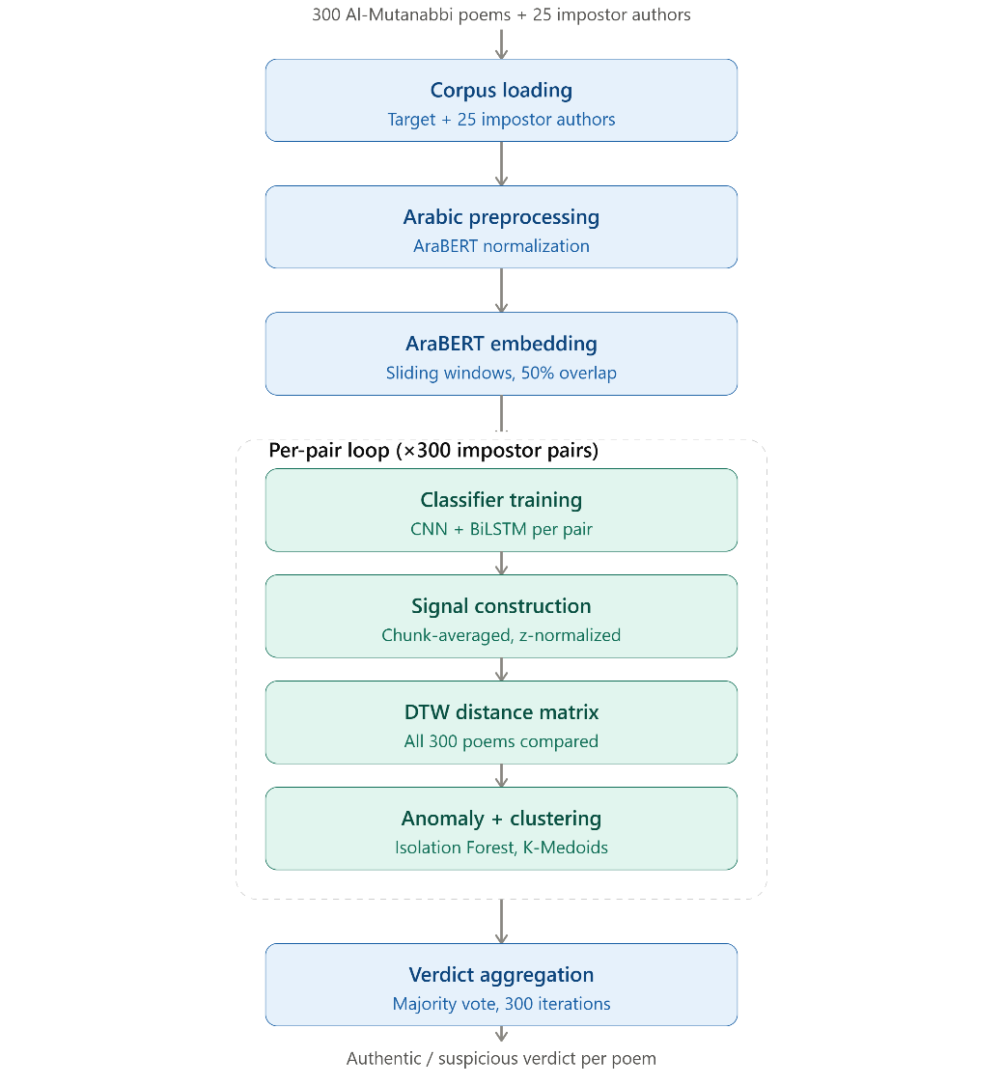

  - System Overview
The system is a modular, script based research pipeline that accepts a corpus of Arabic poems and produces an authorship consistency verdict for each poem, without requiring labeled training data for the target author. It is designed for reproducibility (cached embeddings, resumable iterations, deterministic seeding) rather than interactive end user operation.
At a high level, the framework consists of the following stages:
- Corpus loading (target author + impostor authors), with disk cached loading via pickle
- Arabic text preprocessing using AraBERT normalization
- Contextual embedding extraction using AraBERTv02 (sliding windows, 50% overlap)
- Per impostor pair binary classifier training (CNN + Bidirectional LSTM, referred to in the code as "RCNNA")
- Stylometric signal construction from classifier outputs on the target author's poems
- Signal comparison across all poems using Dynamic Time Warping
- Anomaly detection (Isolation Forest) and clustering (K-Medoids) on the resulting distance matrix
- Aggregation of per iteration results across all impostor pairs into a final authorship verdict per poem
Each stage is implemented as a distinct, independently testable function, and the entire loop over impostor pairs (300 pairs, one per unique combination of the 25 impostor authors) is orchestrated by a single main() routine that supports safe resume after interruption via per iteration "done" markers.
  - Algorithmic Pipeline
For each of the 300 impostor pairs $\left(Z_{i} , Z_{j}\right)$, the system independently trains one binary classifier to distinguish embedding windows of $Z_{i}$from $Z_{j}$. This training uses only impostor data the target author's poems are never used to train any classifier, preserving the impostor based verification principle from Phase A.
Once trained, the classifier is applied to every embedding window of every Al-Mutanabbi poem, producing a continuous prediction score per window. These scores are averaged in fixed size chunks and z score normalized to produce one stylometric signal per poem, for that impostor pair. Pairwise DTW distances are computed between all poems' signals, yielding a 300×300 distance matrix. Isolation Forest is applied to this matrix to assign each poem an anomaly score for that iteration, and K-Medoids ($k=2$) clusters the poems into two groups based on the same distance matrix.
This entire process train, score, build signals, compute distances, detect anomalies, cluster is repeated independently for all 300 impostor pairs. The final authorship verdict for each poem is obtained only after all iterations complete, by aggregating the 300 per iteration anomaly scores (Chapter 4 gives the full aggregation rule).
Figure 2: pseudocode of the per iteration algorithm
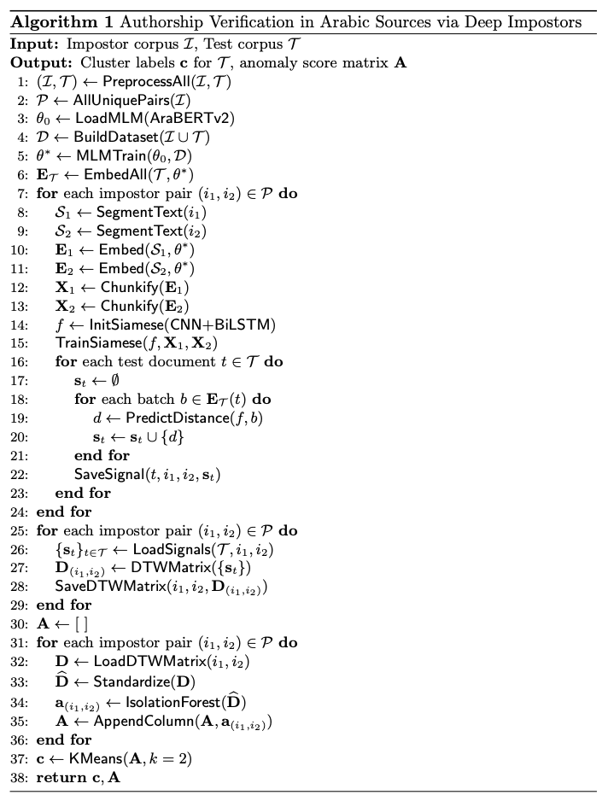

- Experiment Setup
  - Dataset
The dataset consists of a single target author, Al-Mutanabbi, and 25 impostor poets spanning a broad range of periods and poetic genres, selected to expose the classifiers to diverse contrastive stylistic patterns rather than a narrow stylistic neighborhood.
Target group: 300 poems attributed to Al-Mutanabbi, each stored as an individual text file and treated as one verification unit.
Impostor group: 25 poets, loaded from per author folders. Where more than 300 poems were available for a given impostor, up to 300 were randomly sampled (fixed seed = 42) to keep impostor corpora comparably sized to the target corpus. Every unique pair of impostors is used to train one classifier, giving (252)=300\binom{25}{2} = 300
(225​)=300 impostor pairs and therefore 300 independent iterations of the full pipeline.

Table 1 lists the impostor poets and the stylistic rationale for each, as selected for this study.
No. | Author | Role | Why it is a Good Impostor for Al-Mutanabbi
1 | Al-Mutanabbi | Target Author | Primary author whose writing style is analyzed throughout this study.
2 | Ibn al-Rumi | Impostor | Rich descriptive poetry with a highly personal style that differs from Al-Mutanabbi's rhetorical and heroic voice.
3 | Ibn Nubata al-Misri | Impostor | Represents later classical Arabic poetry with elaborate rhetorical ornamentation and a distinct literary tradition.
4 | Abu al-Ala al-Ma'arri | Impostor | Philosophical and introspective poetry that contrasts with Al-Mutanabbi's themes of pride, power, and ambition.
5 | Ibn al-Wardi | Impostor | Didactic and moralistic poetry with concise expression and different stylistic priorities.
6 | Abu Nuwas | Impostor | Known for wine and love poetry, providing strong thematic and lexical contrast.
7 | Al-Sharif al-Aqili | Impostor | Classical poetic style with different rhetorical preferences and literary themes.
8 | Abd al-Ghani al-Nabulsi | Impostor | Mystical and Sufi poetry characterized by spiritual vocabulary and symbolic imagery.
9 | Al-Buhturi | Impostor | Renowned for elegant panegyric poetry, making him a stylistically similar yet distinguishable impostor.
10 | Muhyiddin Ibn Arabi | Impostor | Mystical and philosophical verse with highly symbolic language unlike Al-Mutanabbi's direct expression.
11 | Safi al-Din al-Hilli | Impostor | Rich rhetorical style and extensive literary devices challenge stylistic discrimination.
12 | Al-Ahnaf al-Akbari | Impostor | Classical Arabic poetry with a distinct authorial voice and thematic focus.
13 | Al-Farazdaq | Impostor | Tribal and satirical poetry from the Umayyad period offering historical and stylistic diversity.
14 | Salah al-Din al-Safadi | Impostor | Later medieval literary style with different linguistic and poetic characteristics.
15 | Abu al-Atahiyah | Impostor | Ascetic and moral poetry that contrasts sharply with Al-Mutanabbi's heroic worldview.
16 | Ibn al-Mu'tazz | Impostor | Abbasid court poetry emphasizing rhetorical elegance and artistic refinement.
17 | Lisan al-Din Ibn al-Khatib | Impostor | Andalusian poetic tradition introducing regional stylistic diversity.
18 | Abu al-Fath al-Busti | Impostor | Wisdom and ethical poetry with concise aphoristic expression.
19 | Al-Sanawbari | Impostor | Nature poetry rich in environmental imagery and descriptive vocabulary.
20 | Al-Qadi al-Fadil | Impostor | Literary poetry influenced by his administrative and epistolary writing style.
21 | Al-Sharif al-Radi | Impostor | Elevated classical diction and refined poetic language provide a close stylistic comparison.
22 | Al-Kumayt Ibn Zayd | Impostor | Political and tribal poetry distinguished by ideological themes and early Islamic style.
23 | Al-Hays Bays | Impostor | Humorous and satirical poetry introducing stylistic diversity within the impostor corpus.
24 | Khalid al-Katib | Impostor | Courtly literary style reflecting formal poetic expression and administrative culture.
25 | Bashar Ibn Burd | Impostor | Innovative Abbasid poet known for bold imagery and distinctive linguistic creativity.
26 | Abd al-Muhsin al-Suri | Impostor | Later classical poetry contributing additional lexical and stylistic diversity to the dataset.

Validation control samples. Two well established, canonically accepted Al-Mutanabbi poems including his celebrated satire against Kāfūr al-Ikhshīdī, "ʿĪdun bi-ʾayyati ḥālin ʿudta yā ʿīd" were duplicated and inserted into the 300 poem evaluation corpus as control samples (appearing in results as "Copy of text to classify 1/2"). Because these poems' authenticity is not in question, a reliable framework should consistently classify them as authentic; this is used as a sanity check in Chapter 5 rather than as part of the verification task itself.

  - Preprocessing
Preprocessing is applied uniformly to the target and impostor texts, and consists of the steps actually implemented in the pipeline:
- Text normalization via the AraBERT preprocessor (ArabertPreprocessor), which performs AraBERT's standard orthographic normalization (diacritic removal, alef/hamza normalization, elongation removal, punctuation handling) as part of preparing text for the AraBERTv02 tokenizer.
- Whitespace tokenization of the normalized text.
- Filtering to retain only tokens containing Arabic Unicode characters (U+0600–U+06FF), removing residual Latin characters, digits, and punctuation artifacts.
This is intentionally a lighter preprocessing chain than the morphological segmentation (e.g. Farasa) and explicit stopword removal/stemming discussed as options in Phase A; the implemented pipeline relies on AraBERT's own normalization and tokenizer rather than a separate segmentation stage.

  - Model Configuration
Contextual embeddings are generated using AraBERTv02 base (aubmindlab/bert base arabertv02) via the HuggingFace transformers library. Each tokenized text is split into overlapping sliding windows and encoded independently; the last hidden state of each window (768 dimensional per token) is used as the embedding representation, rather than a single pooled vector.
The classifier referred to in the implementation as RCNNA combines onedimensional convolutional layers with stacked bidirectional LSTM layers: two Conv1D+MaxPooling blocks for local stylistic feature extraction, followed by two stacked BiLSTM layers for longer range sequential dependencies, then a dense sigmoid layer, dropout, and a final softmax output layer for binary classification between the two impostors in a pair.
Development was performed in Python using TensorFlow/Keras (classifier), PyTorch/HuggingFace Transformers (embeddings), scikit learn and scikit learn extra (Isolation Forest, K-Medoids), and dtaidistance (DTW), on Google Colab with GPU acceleration. Table 2 lists the complete configuration as implemented.

Table 2. Experimental configuration and model hyperparameters.
Category | Component | Parameter | Value
Environment | Programming language | Version | Python 3.x
 | Deep learning framework | Library | TensorFlow / Keras
 | Embedding framework | Library | HuggingFace Transformers, PyTorch
 | Development platform | Environment | Google Colab (GPU)
 | Reproducibility | Random seed | 42
Corpus | Target author | Poems | 300 (Al-Mutanabbi)
 | Impostor authors | Count | 25
 | Impostor pairs | Count | 300 ($\left({25 \atop 2}\right)$)
 | Impostor poems per author | Cap | Up to 300 (random sample if more available)
Segmentation | Chunk size | Words | 160
 | Embedding window | Tokens | 20 (chunk_size / 8)
 | Window overlap | Fraction | 0.5
 | Signal chunk averaging | k | 2
Classifier (RCNNA) | Conv1D kernel sizes | — | [3, 5]
 | Conv1D filters | Count | 128
 | Pooling size | — | 1
 | BiLSTM units | Per layer | 128
 | Dense (pre output) units | — | 128
 | Dropout | Probability | 0.50
 | Output classes | — | 2
 | Optimizer / loss | — | Adam / categorical cross entropy
 | Max epochs | — | 50 (early stopping, patience 5, monitor val_loss)
 | Train/validation split | — | 75% / 25%, stratified
 | Class balancing | Augmentation factor | 2× (after balancing shorter impostor to longer)
Anomaly detection | Isolation Forest trees | n_estimators | 100
 | High score percentile threshold | — | 90th
Clustering | Algorithm | — | K-Medoids
 | Clusters | k | 2
Signal comparison | Distance metric | — | Dynamic Time Warping

Observed training performance across freshly trained classifiers in this run: mean training accuracy 0.997 (range 0.987–1.000), mean validation accuracy 0.979 (range 0.929–0.999) indicating that impostor pairs are, in general, highly separable at the embedding window level, which is the property the signal construction stage relies on.
- Research Process
  - Implementation Details
The pipeline was implemented as a single Colab notebook organized into clearly separated stages (installation, imports, configuration, AraBERT initialization, preprocessing/embedding functions, data loading, dataset construction, model definition, classification pipeline, main execution loop, aggregation, visualization, and evaluation), each isolated into its own function so that individual stages could be tested and rerun independently.
Caching and resumability. Because the full experiment involves training 300 independent classifiers one per impostor pair the implementation was built around aggressive caching and resumability rather than a single uninterrupted run:
- Raw text loading (get_mutanabbi_data, get_imposter_by_name) is cached to disk via pickle, so re running the notebook does not require re reading text files from Google Drive.
- AraBERT embeddings are cached per author per window configuration (cache_emb_{name}_{dbs}_{overlap}.pkl), so changing an unrelated hyperparameter does not force re embedding.
- Each iteration's trained classifier is saved to disk (best_model{iteration}.h5); if a saved model already exists for a given iteration, classify_text() loads it instead of retraining.
- After each of the 300 iterations, results (Isolation Forest scores, cluster labels, distance matrices) are written to CSV/.npy files, and a per iteration "done" marker file is written to a logs directory.
- The main loop (main()) checks for these done markers on startup and skips any already completed iteration, and the aggregation step separately restores sum_dicForest/sum_labels from the saved CSVs on a cold reload (e.g. after a Colab runtime disconnect).
This design was necessary in practice: training 300 CNN+BiLSTM classifiers sequentially, each with early stopping over up to 50 epochs, is a long running job that is highly susceptible to Colab runtime timeouts and disconnects, and the resume logic allowed the full sweep to be completed incrementally across multiple sessions rather than requiring one continuous run.
Memory management. gc.collect() is called after embedding extraction and after each classifier training pass, and TensorFlow GPU memory growth is enabled at startup, to reduce the risk of out of memory failures given the number of models trained across the full sweep.
Handling AraBERT's input length limit. Since AraBERT (like other BERT based models) has a fixed maximum input length, full poems cannot be embedded in a single forward pass. This is handled by extracting embeddings from overlapping sliding windows of fixed token length rather than from the whole document at once, with the overlap (50%) chosen to preserve context across window boundaries.
  - Challenges and Adjustments
Classifier architecture. Phase A discussed several possible deep classifier architectures (FNN, CNN, BiLSTM, finetuned BERT heads) without committing to one specific design. The implemented system settled on a combined CNN + Bidirectional LSTM classifier (Conv1D for local stylistic motifs, BiLSTM for longer range sequential dependencies), applied directly to the AraBERT embedding sequence rather than to a single pooled vector. This was retained as the final design based on the strong and consistent separability it achieved between impostor pairs (validation accuracy generally above 0.93, often above 0.98).
Clustering algorithm. Phase A specified K-Means ($k=2$) for the final clustering stage. During implementation this was changed to K-Medoids ($k=2$). K-Means computes cluster centroids as the mean of assigned points, which makes it sensitive to exactly the kind of outlier points the framework is trying to detect a small number of strongly anomalous poems can pull a centroid away from the bulk of genuinely consistent poems. K-Medoids instead uses actual data points as cluster representatives, which is more robust to this kind of outlier influence and was judged a better fit for an anomaly oriented clustering step.
Impostor corpus imbalance. Individual impostor poets naturally have different amounts of surviving text. Rather than discarding this imbalance, create_XY() balances each pair by repeating the shorter impostor's embedding windows up to the length of the longer one (with random sampling for any remainder), then applies a further ×2 augmentation to both classes before training. This keeps classifier training pairs roughly class balanced without discarding usable data from the smaller impostor.
Aggregating 300 independent, noisy iterations into one decision. Because each of the 300 impostor pair iterations produces its own anomaly score per poem, the final verdict could not rely on a single iteration's result some pairs are more discriminative than others, and a single classifier's noise could flag a genuinely authentic poem or miss a genuinely inconsistent one. The implemented aggregation (Chapter 5) instead uses the mean anomaly score across all 300 iterations plus a majority vote fallback, which smooths out per pair noise and only flags a poem when its anomalous behavior is consistent across the sweep rather than an artifact of one specific impostor comparison.
Validating that the pipeline doesn't over flag genuine text. As noted in Chapter 3, two canonically accepted Al-Mutanabbi poems were deliberately duplicated into the evaluation corpus as control samples, specifically to catch a failure mode where the framework might flag stylistic outliers too aggressively. Both controls were consistently scored authentic across the full sweep (Chapter 5), which was used as a basic sanity check on the aggregation logic before trusting its results on the genuinely disputed portion of the corpus.

- Experiment Results
  - Classifier Training Performance
Across the 300 impostor pair classifiers trained during this run, training accuracy converged consistently to near perfect separation between impostor pairs (mean 0.997, range 0.987–1.000), while validation accuracy remained high and stable (mean 0.979, range 0.929–0.999). Figure 3 shows a representative training/validation accuracy curve for one iteration, showing rapid convergence within the first 4–5 epochs and early stopping typically triggering between epochs 9 and 14.

Figure 3: sample training accuracy curve
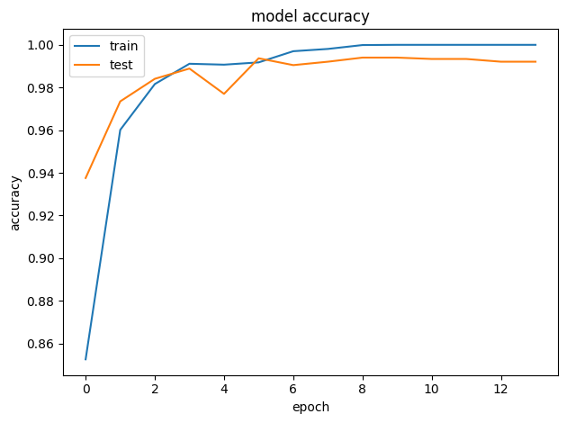
This consistently high separability confirms that the AraBERT embeddings combined with the CNN+BiLSTM classifier can reliably distinguish between different impostor poets' writing styles the precondition for the stylometric signals built from these classifiers to be meaningful.
  - Aggregated Authorship Decision
After all 300 iterations completed, per poem anomaly scores were aggregated by mean across all impostor pairs. Of the 300 poems evaluated, 294 were classified as authentic and 6 as suspicious, with an overall mean anomaly score of 0.048 (std 0.030) across the corpus.
Figure 4 shows the final per poem anomaly scores, sorted from most to least anomalous; the small cluster of poems with negative mean scores (red) separates clearly from the broad majority with positive scores (green).
Figure 4: "Authorship anomaly scores
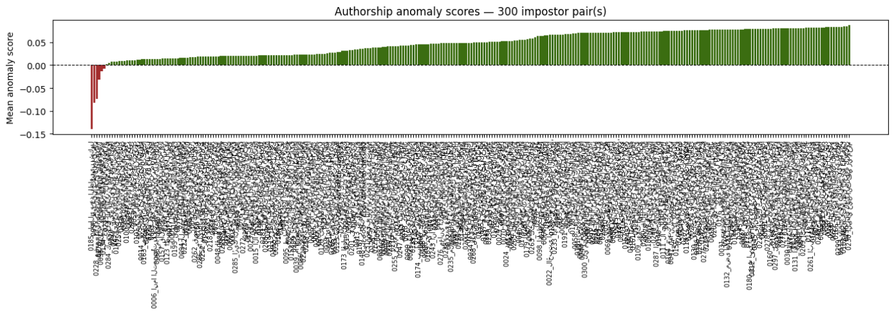
Figure 5 shows the same result as a verdict count summary.
Figure 5: Final verdict counts
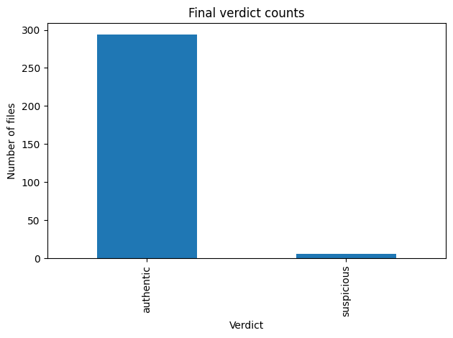

  - Poems Flagged as Suspicious
The six poems below had a mean anomaly score below zero the decision threshold averaged across all 300 impostor pair iterations. They are identified here by their opening line identifiers, as used in the corpus.
Table 3. Poems flagged as suspicious.
# | Opening line (identifier) | Mean anomaly score | Min score | Votes flagged (of 300)
1 | 0185 — ليالي بعد الظاعنين شكول | −0.139 | −0.193 | 300
2 | 0096 — طوال قنا تطاعنها قصار | −0.083 | −0.230 | 300
3 | 0228 — عقبى اليمين على عقبى الوغى ندم | −0.073 | −0.186 | 300
4 | 0178 — أجاب دمعي وما الداعي سوى طلل | −0.031 | −0.131 | 284
5 | 0035 — أغالب فيك الشوق والشوق أغلب | −0.013 | −0.175 | 190
6 | 0134 — غيري بأكثر هذا الناس ينخدع | −0.008 | −0.171 | 169

The first three poems were flagged as anomalous in all 300 iterations (vote count 300/300) and have the most negative mean scores, indicating strong and consistent stylistic divergence regardless of which impostor pair was used for comparison. The remaining three sit closer to the decision boundary (scores near zero, flagged in only 56–95% of iterations), suggesting a more marginal, less consistent signal.
  - Signal and Distance Based Analysis
Figure 6 shows representative stylometric signals (chunk averaged, z score normalized classifier scores) for a sample of poems from the final iteration, illustrating how signal shape varies in length and volatility across documents of different sizes.
Figure 6: Stylometric signals
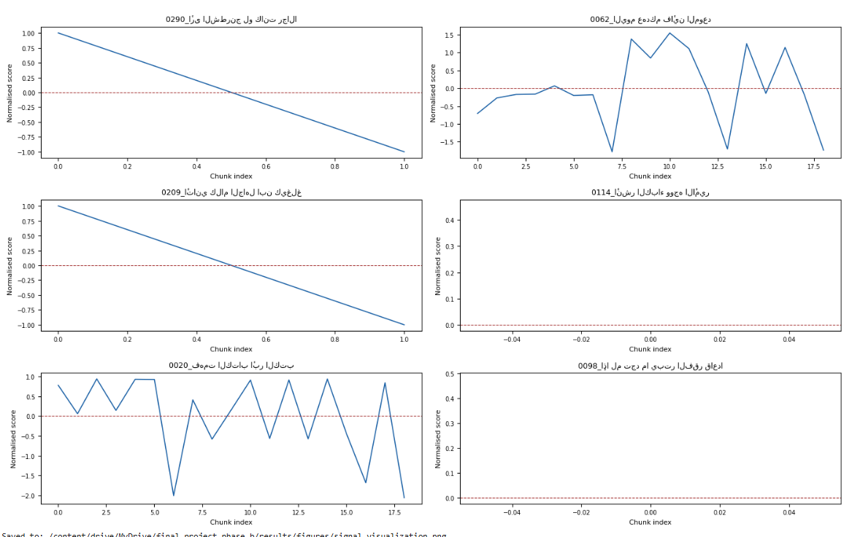

Figure 7 plots each poem's mean anomaly score against the K-Medoids cluster label assigned in the final iteration. Two clusters are visible: a smaller, lower scoring cluster containing the flagged and borderline poems, and a larger, higher scoring cluster containing the bulk of the corpus.
Figure 7: Mean anomaly score per file, colored by cluster
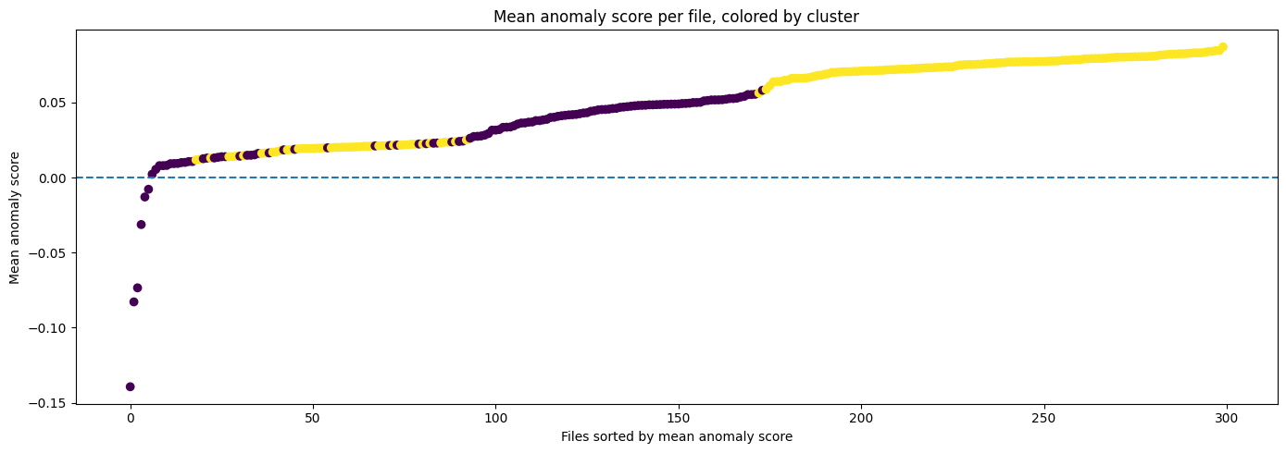
Figure 8 and Figure 9 summarize this cluster separation numerically: cluster 0 has a lower average Isolation Forest score (≈0.030) than cluster 1 (≈0.060), and the box plot confirms cluster 0's distribution is both lower and wider, consistent with it absorbing the outlier poems.
Figure 8: Average Isolation Forest Score per Cluster
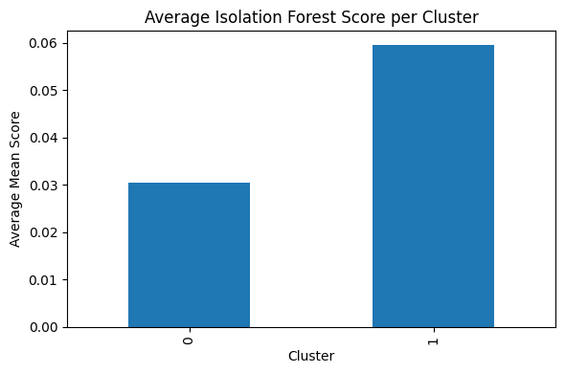
Figure 9: Distribution of Mean Scores by Cluster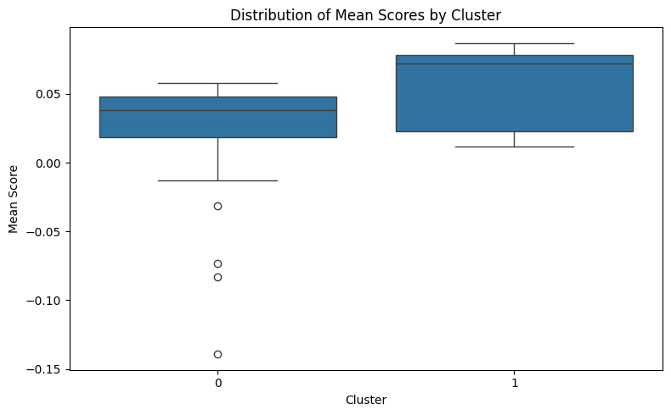
This agreement between the Isolation Forest based anomaly ranking and the independent K-Medoids clustering both isolating largely the same small set of poems supports the reliability of the flagged poems rather than attributing them to noise in a single detection method.
  - Validation via Control Samples
As discussed in Chapter 3, two canonically accepted Al-Mutanabbi poems were duplicated into the corpus as control samples. Both were scored authentic in the final aggregation (mean scores 0.029 and 0.036, well within the authentic range, and neither ever appears in the suspicious set). This provides a basic sanity check that the framework's anomaly detection is not simply flagging poems indiscriminately, and that a poem needs a genuinely consistent stylistic deviation across the impostor sweep to be flagged.
- Conclusion and Future Work
This project implemented and evaluated a complete Deep Impostors based framework for Arabic authorship verification, applied to 300 poems attributed to Al-Mutanabbi against 25 impostor poets, executed end to end across all 300 impostor pair iterations.
The results support the framework's core premises. Classifiers trained exclusively on impostor pairs never on the target author achieved consistently high separability (mean validation accuracy 0.979), and aggregating anomaly scores across all 300 iterations produced a stable verdict: 294 of 300 poems classified as stylistically consistent, 6 flagged as anomalous, with the three strongest flags isolated in every single iteration. Agreement between Isolation Forest and independent K-Medoids clustering, together with two canonically authentic control poems both correctly scored as authentic, supports that these results reflect genuine stylistic signal rather than pipeline noise.
Two implementation decisions deliberately diverged from the Phase A plan: the classifier architecture was fixed to CNN+BiLSTM rather than explored across candidates, and K-Medoids replaced the originally proposed K-Means, chosen for its robustness to the outliers the framework is meant to detect. Both are documented in Chapter 4 with their rationale. Training 300 sequential classifiers also pushed against Colab's session limits, making caching, checkpointing, and resumable iterations a practical necessity rather than a convenience.
The evaluation's main limitation is the absence of ground truth labels for disputed authorship: results rest on internal consistency across impostor comparisons and agreement between two unsupervised methods, not on accuracy against known answers. This can show that a poem is stylistically distinct with high consistency, but not confirm why so the six flagged poems are reported as scores rather than claims of misattribution.
Future work could extend this framework in several directions: incorporating confirmed ground truth labels for a subset of disputed Al-Mutanabbi poems (if scholarly consensus exists) to compute supervised metrics alongside the current unsupervised evaluation; testing sensitivity to the fixed chunk size and window overlap; comparing the CNN+BiLSTM classifier against a fine tuned AraBERT classification head; and applying the same pipeline to additional target authors to test how well the framework generalizes beyond a single case study.

References
- Antoun, W., Baly, F., & Hajj, H. (2020). AraBERT: Transformer-based model for Arabic language understanding. Proceedings of the 12th Language Resources and Evaluation Conference (LREC). https://arxiv.org/abs/2003.00104
- Devlin, J., Chang, M.-W., Lee, K., & Toutanova, K. (2019). BERT: Pre-training of deep bidirectional transformers for language understanding. Proceedings of NAACL-HLT 2019, 4171–4186. https://doi.org/10.18653/v1/N19-1423
- Kaufman, L., & Rousseeuw, P. J. (1990). Partitioning around medoids (Program PAM). In L. Kaufman & P. J. Rousseeuw (Eds.), Finding groups in data: An introduction to cluster analysis (pp. 68–125). John Wiley & Sons. https://doi.org/10.1002/9780470316801.ch2
- Larkin, M. (2008). Al-Mutanabbi: Voice of the ʿAbbasid poetic ideal. Oneworld Publications.
- Liu, F. T., Ting, K. M., & Zhou, Z.-H. (2008). Isolation forest. Proceedings of the 8th IEEE International Conference on Data Mining, 413–422. https://doi.org/10.1109/ICDM.2008.17
- Müller, M. (2007). Dynamic time warping. In Information retrieval for music and motion (pp. 69–84). Springer. https://doi.org/10.1007/978-3-540-74048-3_4
- Sakoe, H., & Chiba, S. (1978). Dynamic programming algorithm optimization for spoken word recognition. IEEE Transactions on Acoustics, Speech, and Signal Processing, 26(1), 43–49.
- Volkovich, Z., & Avros, R. (2025). Comprehension of the Shakespeare authorship question through the Deep Impostors approach. Digital Scholarship in the Humanities. https://doi.org/10.1093/llc/fqaf009

User Guide
System Overview
This system is a research pipeline, not an interactive application it is operated by running notebook cells in sequence inside Google Colab, not through a graphical interface. It takes a corpus of Arabic poems (one target author, several impostor authors) and produces, after a full run, a per poem authorship consistency verdict together with supporting figures and CSV reports.

Requirements
- A Google account with access to Google Drive (the notebook mounts Drive for all data, caching, and output storage)
- Google Colab, ideally with GPU acceleration enabled (Runtime → Change runtime type → GPU) classifier training is CPU feasible but substantially slower
- No local installation is required; all dependencies are installed by the notebook's first cell

Repository Location
https://github.com/nour-dabbah/CapstoneProject.git

Files Provided
- Capstone_Project_Phase_b.ipynb — the complete pipeline notebook
- A data_base/ folder (on Google Drive, not in the repository) containing:
- Mutanabbi/ — the 300 target author poem .txt files
- imposters/<author_name>/ one subfolder per impostor author, each containing that author's poem .txt files

Setup Instructions
- Upload the data_base/ folder to Google Drive at the path MyDrive/final_project_phase_b/data_base/ (or update BASE_DIR in the configuration cell to match a different location).
- Open the notebook in Google Colab and set the runtime type to GPU.
- Run the Installation cell once per Colab session it installs numpy<2, scipy==1.12.0, tensorflow, scikit learn extra, dtaidistance, h5py, gensim==4.3.2, netron, transformers, sentencepiece, arabert, graphviz, and pydot.
- Run the Imports, Configuration and Paths, and NLP Downloads and AraBERT Initialization cells in order. The configuration cell mounts Google Drive and creates the output folder structure (results/figures, results/reports, results/distance_matrices, models, cache, logs) automatically if it does not already exist.
- Run the remaining function definition cells (preprocessing, data loading, dataset construction, model definition, analysis helpers, classification pipeline) these only define functions and run quickly.
System Operation Flow
- Run the Main Execution Loop cell. This calls main(), which loads the target author's poems, enumerates all impostor pairs, and for each pair not already completed trains a classifier, builds the stylometric signals, computes the DTW distance matrix, runs Isolation Forest and K-Medoids, and saves results to Drive before moving to the next pair.
- Resuming after a disconnect. If the Colab runtime disconnects or times out mid run, simply re run the notebook from the top. Cached embeddings, saved models, and per iteration "done" markers mean already completed iterations are skipped automatically rather than recomputed; main() picks up from the first incomplete iteration.
- Once all 300 iterations are complete, run the Aggregation and Final Decision Table cell. This reads all per iteration results (restoring them from saved CSVs if the current session did not run every iteration itself), computes the mean/min/voted anomaly scores per poem, assigns a final authentic/suspicious verdict, and saves final_decision_table.csv.
- Run the Visualizations cells to generate and display the six result figures described in Chapter 5 (signal plots, anomaly score charts, cluster scatter, verdict counts, per cluster comparisons).
- Run the Evaluation Metrics cell. If you have confirmed ground truth labels for specific poems, populate the known_authentic and known_spurious lists at the top of this cell to compute accuracy/precision/recall/F1 (Mode 1). Leaving both lists empty runs Mode 2 instead, producing the unsupervised score distribution summary used in this report.

Google Drive Output Structure
All outputs are written under MyDrive/final_project_phase_b/:
final_project_phase_b/
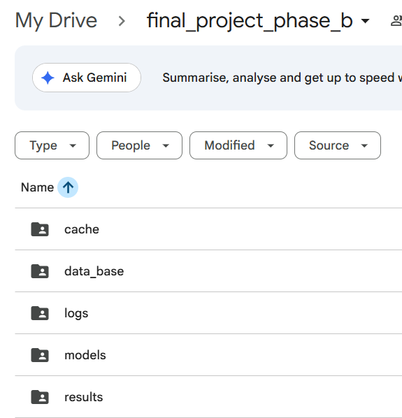
final_project_phase_b/ data_base
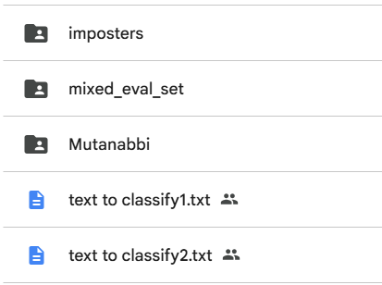

Maintenance Guide
Project Overview
This system implements the Deep Impostors framework for Arabic authorship verification, applied to Al-Mutanabbi's poetry against 25 impostor authors. It is a single notebook research pipeline rather than a deployed service, so "maintenance" here refers to keeping the notebook runnable, extending it to new authors or configurations, and understanding where to intervene if a run needs to be modified.
System Operating Environment
- Platform: Google Colab (GPU runtime recommended)
- Storage: Google Drive, mounted at /content/drive, with all data, caches, models, and results under MyDrive/final_project_phase_b/
- Core libraries: TensorFlow/Keras (classifier), PyTorch + HuggingFace Transformers + arabert (AraBERT embeddings), scikit learn + scikit learn extra (Isolation Forest, K-Medoids), dtaidistance (DTW), NLTK (tokenization resources), pandas/NumPy/Matplotlib/Seaborn (data handling and plotting)
Project Structure
The notebook is organized into 15 numbered sections (visible as markdown headers): Installation, Imports, Configuration and Paths, NLP Downloads and AraBERT Initialization, Global State Variables, Preprocessing and Embedding Functions, Data Loading Functions, Dataset Construction, Model Definition, Analysis Helpers, Classification Pipeline, Main Execution Loop, Aggregation and Final Decision Table, Visualizations, and Evaluation Metrics. Each section should be run in order on a fresh runtime; sections after the Main Execution Loop can be re run independently once iteration results exist on Drive.
Maintenance Guidelines
Updating or Adding New Text Data
To add poems to the target author's corpus, add .txt files to DATA_DIR/Mutanabbi/. To add or replace an impostor author, add a new subfolder under DATA_DIR/imposters/ named after that author. After changing the corpus, delete the corresponding cached pickle files in cache/ (e.g. cache_mutanabbi.pkl, or cache_emb_<author>_<window-config>.pkl) so the pipeline re reads and re embeds the updated data rather than serving stale cached results.
Changing the Test Author
Changing the target author requires: renaming/replacing the Mutanabbi folder under DATA_DIR, updating the get_mutanabbi_data() function's folder reference and the 'Mutanabbi' key used throughout data_base_dict, clearing the Mutanabbi related caches, and re running the full pipeline from the Main Execution Loop onward (all 300 classifiers are impostor pair specific and do not need retraining, but every classifier's scoring pass over the target author must be redone).
Modifying Model Architecture or Parameters
Classifier hyperparameters (kernel sizes, filter count, LSTM units, dropout, epochs, etc.) are set as local variables inside classify_text(), and the architecture itself is defined in rcnna(). Changing either requires deleting all saved models in models/ (best_model{iteration}.h5) so classify_text() retrains rather than loading stale models, since the code currently has no versioning to distinguish saved models trained under different hyperparameter configurations.
Replacing the Embedding Model
The embedding model is initialized once in the AraBERT Initialization cell (MODEL_NAME = "aubmindlab/bert-base-arabertv02") and retrieved throughout the pipeline via word2vec_algorithm(), which despite its legacy name always returns the AraBERT tokenizer/model/preprocessor bundle. Swapping in a different embedding model requires updating MODEL_NAME, verifying the new model's hidden state dimensionality matches what rcnna() expects (currently hardcoded to 768 in the pipeline call), and clearing all embedding caches.
Extending Analysis and Classification
New anomaly detection or clustering methods can be added inside classify_text() alongside the existing Isolation Forest (presentation()) and K-Medoids calls, storing results in a similarly structured dictionary keyed by iteration number so they integrate with the existing aggregation cell without modification. New evaluation metrics can be added to the Evaluation Metrics cell, following the existing Mode 1 (ground truth) / Mode 2 (unsupervised) branching structure.
Output Management and Reproducibility
The random seed is fixed (random.seed(42)) for impostor sampling and train/validation splitting, but full run to run reproducibility also depends on GPU non determinism in TensorFlow, which is not separately controlled in this implementation. All intermediate and final outputs are versioned by iteration number rather than overwritten, so re running a subset of iterations does not destroy previously completed results only deleting cache/model/log files for a specific iteration forces it to be recomputed.
Portability and Future Use
Because all paths are derived from the single BASE_DIR constant, the entire pipeline can be relocated to a different Drive folder (or adapted to a non Colab environment) by changing that one constant and removing the Colab specific drive.mount() call, provided the same directory structure (data_base/, cache/, models/, logs/, results/...) is recreated at the new location.

